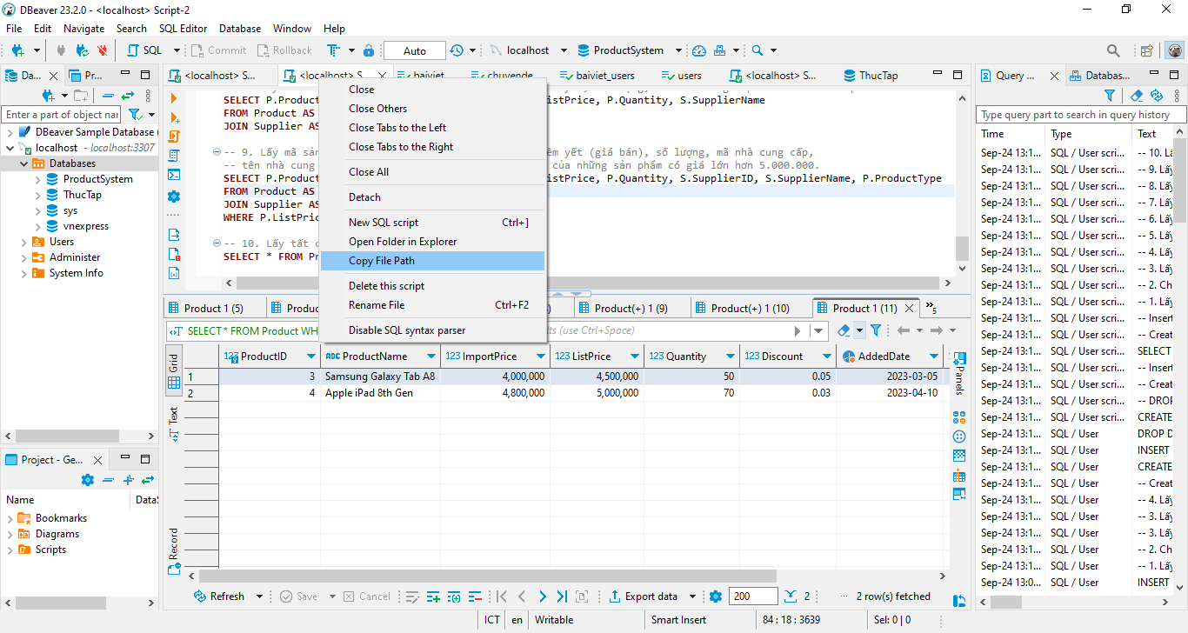

C:\Users\nguye\AppData\Roaming\DBeaverData\workspace6\General\Scripts\Script-2.sql  
